Software Documentation

1. Software Overview
- MicroPython software communicates the code to the ESP32.
- Platforms used- MicroPython.

2. System Logic
- Code is run via MicroPython.
- ESP32 receives data.
- High/low values of the pins are read.
- If high- neopixel lights up and score is displayed on oled. If low- no change.
- When push button is pressed, pins are raised and kept back by the servo and hence reset.
- When the IRs detect the ball, the oled shows “Gutter!”

3. Flowchart
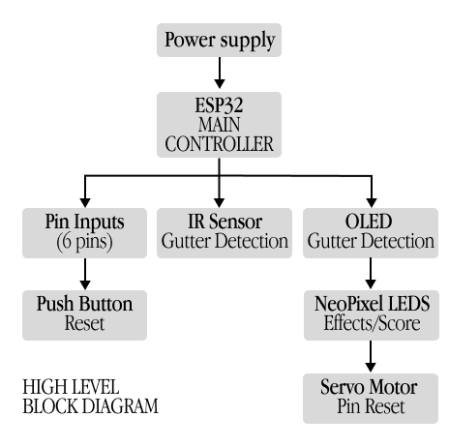

4. App Flow (If MIT App Inventor)
N/A

